Aquatic Facilities
Accessibility Information for Websites




Recreation Aotearoa, supported by Be. Lab June, 2024






Te Whai Oranga

Content

3 | Accessibility
4 | Purpose
4 | Recommendations
5 | Accessible website design
8 | Accessibility statement
9 | Accessibility page
10 | Getting ready to go
11 | Arriving and getting in
12 | Getting around
15 | Facilities and services
16 | Considerations when preparing the information
18 | Other resources and organisations to support
21 | Aquatics accessibility information checklist

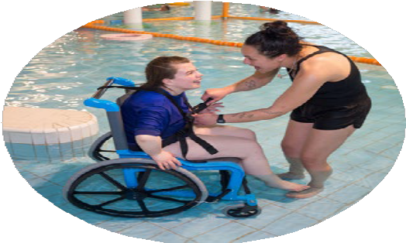
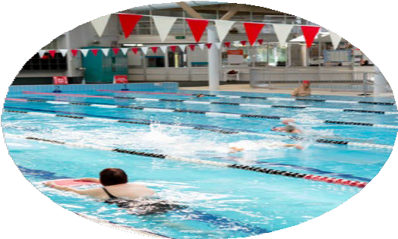
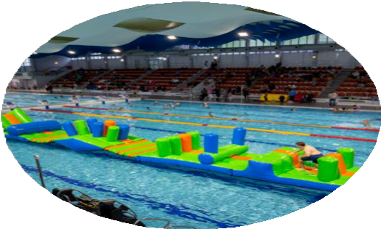

Accessibility

Accessibility is about enabling every member of society to fully participate and enjoy products, services, and places throughout Aotearoa.

We know that 24% of New Zealanders have been identified as having a disability.

We also know that improved accessibility helps older people, pregnant women and parents with young children, people with neurodiversity, people with temporary injury or chronic conditions or English as a second language and their friends, family, and caregivers.

Being digitally inclusive is a natural extension of good customer service. This means being welcoming to all and going out of your way to meet customer needs. In fact, a 2020 survey of people with access needs revealed a welcoming customer service was the number-one enabling factor of accessibility! (Access 2020 Report).

Purpose

The purpose of this document is to provide Aquatic Facilities in Aotearoa with guidelines and top tips to ensure their websites and accessibility pages provide key information for the access community.

The intention is to elaborate on the current level of accessibility for all access users. Its key approach would be to ensure that all accessible areas have been appropriately covered, while being clear about areas where access may be more challenging.

Recommendations

Web accessibility allows people with different access needs to connect with your centre.
From Be.’s 2020 survey of 1,500 New Zealanders, we know that accessible information on websites is a key enabler to support greater accessibility.

Many people, and especially people with additional access needs, go to a website first and foremost to find information before they visit.

The level and standard of information on a website is an indication of how accommodating the organisation is. This begins with the ability to navigate and access information on the website.

Accessible website design

Websites are often how people will find out about your organisation and what they need to know before arriving.
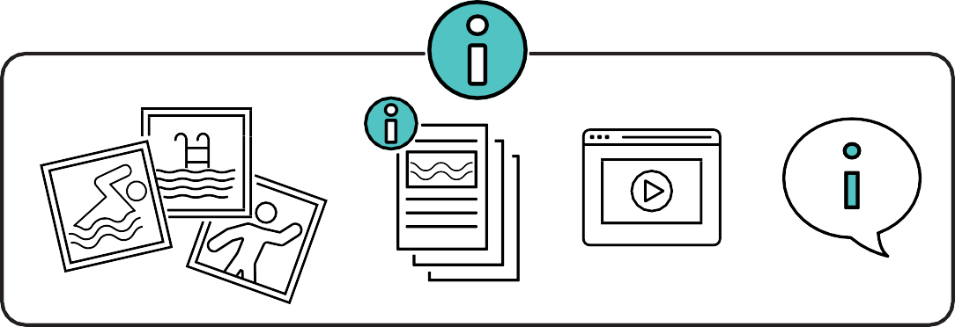
Providing different ways of presenting information helps a variety of access needs. For example, photos are very useful for people that need to see what is there before going, but someone with vision impairment may need descriptive information. Video walk throughs can be useful for people with anxiety to orient themselves in advance, and social stories can support preparation for people that need to know what to expect before their visit to your facility.

Check out Be.’s digital accessibility blog here:
www.belab.co.nz/items/the-whys-and-hows-of-digital-accessibility

Be.’s top tips for improving website accessibility
- Ensure there is strong colour contrast between the text and background on the website for those with visual access needs. Strong colour contrast helps people who have vision impairment to differentiate text from the background etc.
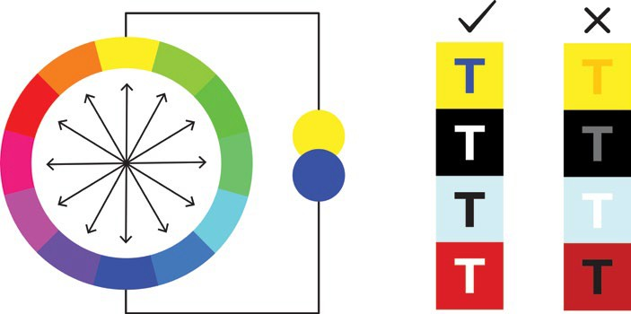

Diagram 1: Colour wheel shows which colours contrast well with each other

- Review the website content and use language that is concise, easy to read and understand. This will ensure that it is accessible to people with all levels of language capability including English as a second language and people who are neurodiverse.

- Use alt text for all photos and images. Alt text describes photos and images for people who are blind or have vision impairment and struggle to see detail. Ensure other multi-media formats (such as video) have captions included, so that people can access any important information shared via audio.

- Display the contact details for your organisation in an easy place to find i.e., the bottom of each web page. People that find it difficult to navigate websites, including people that use screen readers, can struggle to find simple but essential information such as a location address.

- Provide multiple communication options so people can choose their preferred way to contact the business. For example, phone, email, and online chat box.



- Ensure the website is easy to navigate with a simple menu structure - if it can be navigated using a keyboard it is more likely to be screen reader friendly.

- Ensure all links are clearly labelled. When navigating a website with a screen reader, the audio tells the user what the text says, not what the button links to. For example, “Click Here to Contact Us” is more useful than “Click Here”.

- Provide a dedicated accessibility page and/or access guide on your website, with a clearly labelled link on the main menu bar on your home page. This helps customers to plan their trip according to their needs. The Accessibility Page section in this guide describes this in more detail.

Sport New Zealand have a suite of resources to help with digital and document accessibility:

» Sport New Zealand Accessible Websites resources
» Sport New Zealand Accessible Documents resources
» Sport New Zealand Accessible Marketing and Communications resources

Accessibility statement

Let people know about your commitment to creating greater accessibility! Add an accessibility statement on your website, policies, and other communications.
An accessibility statement shows staff and visitors that you are on the journey to creating more inclusive and accessible spaces, and it makes people feel more welcome and comfortable to ask that their needs are met. This can also be a way for visitors to report any accessibility concerns.
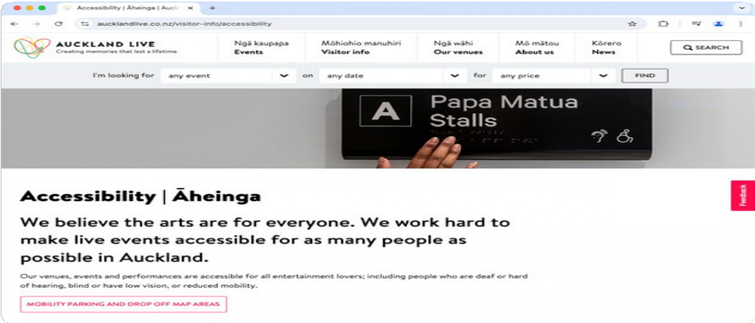
Image 3: Snapshot from Auckland Live’s website

Recreation Aotearoa have used this statement:
“Recreation Conference is on a journey to becoming a fully inclusive, and accessible event for all attendees, and we are committed to ensuring all event delegates have a quality experience.

» To help us achieve this aim, please let us know if there anything we can do to further support your participation in our event, either at registration or by contacting “name” below.
» For support with registering for the event, or for queries regarding accessibility, please contact “name” via email “name”@nzrecreation.org.nz or phone 027 123 4567.
» To ensure your experience is as enjoyable and accessible as possible, we’ve put together a list of the key accessibility features for this event.”

Auckland Live also have a good example on their website, you can find it here: https://www.aucklandlive.co.nz/visitor-info/accessibility

Be.Lab also have a useful Top Tips Article for Communicating your Commitment to Accessibility

Accessibility page

Ensure there is a link on the home page to the accessibility information.
This is the most critical page for any access user and their support person. Listed below are important areas to cover. Provide supporting images of the respective accessible features where possible, so people can decide if it meets their needs, and what further support they might require before arriving.

Below are some options of where you can start to show useful information. It is important to check the information with your community – your community is unique, and asking what they need is a great way to demonstrate your commitment to accessibility. A check list of this information is available in appendix 1.

You can find good examples of accessibility pages on these websites: www. toiponeke.nz/access and https://www.h2oxtream.com/Facility/Accessibility

Getting ready to go

Information | Useful details to include
Location | » Address and links to your Google Map location with nearby landmarks that visitors might be familiar with.  » Describe the car parking situation (including how many mobility parks are available and where they are located/how far away they are from the main entry).  » Outline the access route from the car park or closest public transport to the facility.  Hot tip: It is useful to identify any potential hazards on the access route to the facility such as potential roads to cross, gutter crossing etc.
Map | » Mobility car parks.  » Accessible entrances.  » Facilities like toilets and showers.  » Areas like pools, gym, café.  » Highlight lifts, ramps, and stairs.

Arriving and getting in

Information | Useful details to include
Main Entrance | » Photo and description of the main entrance into the building, including any trip hazards and entrance lips.  » Photos and description of any alternative entrances.  Hot tip: A photo with alt text of the main entrance helps visitors to know what to look for on arrival. It’s also useful to provide information about the door widths and how they open (automatic/slide/push- pull/open button).
Reception Area | » Photo and description of the reception area.  » Let people know what support is available to assist them e.g., helpful staff, alternative  communication options, barrier free entry into the facility.  » If hearing loops are available at the facility.  Hot tip: Reception areas are the first port of call for many visitors and displaying a photo of this area is useful for those who need to know what to expect on arrival at a facility.
Entry Pricing | » How to buy a pass or ticket including payment options.  » Different pass options with prices, including any discounts available.  Hot tip: Being clear about the cost to use a facility and the potential reduced rates available for customers gives people confidence when they visit.

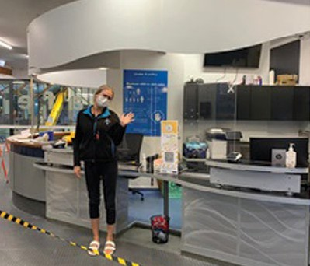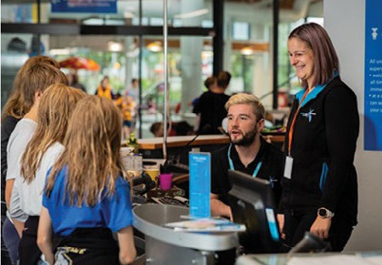
Image 5: Photo of reception from H2O Xtream’s website

Getting around within and participating in aquatics activities

Information | Useful details to include
Changing facilities and family rooms | » Baby changing facilities.  » Family rooms.  » Gender neutral spaces.  » Accessible spaces.  Hot tip: Including photos of these different options is useful for people to determine which changing facilities would best suit their needs. Different changing spaces are also useful to add to your facility map, so people can locate them.

Accessible toilets | » Features such as grab rails, seats, hoists, adult change tables, if there are any emergency call buttons.  » Dimensions of the turning space.  Hot tip: Toilets and changing spaces can often be a barrier for people with high access needs, the more information that’s provided about these spaces, including photos, the better.  Accessible toilets are also useful to add to your facility map.
Pool/spas/ saunas | Describe each pool and location, these descriptions should each include:  » Access into the pool: stepped, ramp and hoist access into pools, including handrails.  » If there is a coloured edge to the pool that could help orientate people with low vision.  » Details of available hoist, including a photo, directions for use and if a staff member is required to use it. Make sure to let pool users know if hoists or accessible entrances are unavailable or out of service.  » Temperature of all pools and saunas.  » Water depths of all pools.  Hot tip: Photos and descriptions of the different access points of each pool are helpful so people can understand if they are able to easily get in and out of the water either assisted or unassisted.
Fitness centre | » How to access the fitness centre or gym.  » Equipment available.  » Classes if any.

Sensory spaces & low sensory times | » Low sensory room or space, if available including what features are available within these spaces.  » Low sensory hours/session times if any, and what to expect during this time.  Hot tip: it can also be useful to outline the different sensory experiences visitors might encounter at your facility. The Access Key developed by Gunyama Park has a good example of this.
Café | » How to access the café.  » How to order and pay for food and drinks.  » What type of food and drinks are available, show a menu if possible.  » Types of tables and seating available.  Hot tip: If there is a café onsite, include this on the accessibility page. Photos of the café, that  include the servery and payment till area would be beneficial for people with access needs.
Play spaces | » Location and design of children’s play area/s.  » Water depth and temperature in water play area/s.

Facilities and services

Information | Useful details to include
Aquatics programmes and lessons | » Information on the different swimming lessons or programmes available including any disability specific initiatives and who can participate.  » Information on any low sensory hours.  » How to book and who to contact for more information.
Mobility equipment | » Up to date photos and descriptions of all the available mobility equipment, so people can understand if they will meet their needs.  Including any pool wheelchairs providing primary access into pool.  » Provide a phone number and email address and invite users to get in touch if they want to  enquire about any mobility equipment available, such as a pool wheelchair or hoist.  It should not be expected that users have to ring ahead to use this equipment, but some users may have queries about how to use the equipment, and the support available.

Key contact | » Provide a contact email and phone number on your accessibility page.  Hot tip: Inviting potential visitors to get in touch with staff, and genuinely welcoming enquiries and feedback on future developments is a good way to demonstrate you are a welcoming, inclusive facility.  This is also a good space to invite visitors to share feedback on their experiences, for continuous improvement.
Getting out safely | » If there is a visual emergency/fire alarm, if not what staff can do to assist people who cannot hear these alarms in the event of an emergency.  » Where the emergency exits are, and which of these are on accessible routes.

Considerations when preparing the information:
» Accessibility is everyone’s responsibility – it is important to get input from your wider team - operations, customer services, lifeguards, digital and marketing team etc.
» The tone and wording needs to fit with your organisation and facility – you want to make sure the information matches the experience people will receive.
» Make sure you check the information you are providing with your staff, for example, can the staff on the ground provide a guided tour for someone with a vision impairment?
» Get a range of customers and service providers to review your information, to make sure it’s relevant for people with a wide range of access needs – it’s more than ramps and toilets.

» Once the document is finished, make sure you share it with your customer service teams – they are often the first port of call for enquiries.
» Accessibility pages and access guides should improve over time, make sure you regularly review and update the information.
» Providing the information in an accessible document for users to download is another way for visitors to access the information – particularly if it’s a lot of information to include on a web page.

Exemplar examples:

Check out these other accessibility pages to explore some different examples:

» Gunyama Park Aquatic and Recreation Centre, Belgravia Leisure, Australia Access Key: https://cdn.sanity.io/files/e4f7rnlq/ production/35f7b9e4cd4a6ed423a51708bb741528ef8f6f0f.pdf
» Te Awa Kairangi ki Uta, H2O Xtream, Wellington https://www.h2oxtream. com/Facility/Accessibility
» Christchurch City Council, Pioneer: https://recandsport.ccc.govt.nz/media/ gxqpwllv/rse-accessibility-digital-guide-for-pioneer-web.pdf

Other resources and organisations to
support:

Recreation Aotearoa and Be. can assist you with your next steps and resources on your accessibility journey.

Recreation Aotearoa are in the process of updating their Aquatics Facility Guidelines with greater support for the aquatics industry to enhance accessibility and inclusion for people with access needs. For support or guidance in the meantime, or if you would like to be part of the Aquatics Accessibility Working Group, supporting this mahi (work) please contact Katie Owen. katie@nzrecreation.org.nz

Be. Lab
Be. Works with businesses and organisations on their accessibility journey, Contact the team at Be. to learn more about how they can support you.

View their range of services on their website:
https://www.belab.co.nz/our-services

Autism NZ & Social Stories
Social stories can be a useful tool to help prepare individuals for their upcoming visit to your facility. Autism NZ Outreach Coordinators in your area can support you to develop your own social story that’s specific to your facility. Find your nearest Autism NZ Outreach Coordinator here: https://autismnz.org.nz/ support-from-us/

Access Maps
Promoting the accessibility of your organisation through Access Maps is another way to share your information via an interactive digital map network for people who seek accessible places, spaces and experiences throughout Aotearoa New Zealand. See www.accessmaps.com or visit https://aktive. org.nz/funding-services/accessibility/ to see how Access Maps serve the community. Or get in touch at info@accessmaps.com

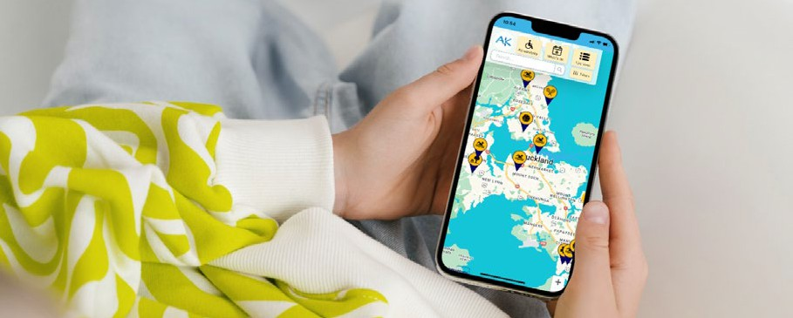

Image 6: screen shots of access map web pages and mobile apps

Cérge
Is a set of companion technologies to help displaying your accessibility information and support with customer service.

Cérge is being used by Belgravia Leisure, and by Trust House Recreation Centre in Masterton: https://belgravialeisure.com.au/cerge-delivering-above- and-beyond-expectations-at-trust-house-recreation-centre/

Firstport
Is the home of disability information and advice in Aotearoa New Zealand.

We also recommend promoting your information via Firstport https://www. firstport.co.nz

Digital assessments
Ensure your website or app can be used by everyone. Be. partner with Access Advisors, New Zealand’s leading digital accessibility experts, to complete accessibility assessments of digital platforms using the Web Content Accessibility Guidelines 2.2 and best practice. The team have both extensive industry and lived experience of access needs.

Access Advisors provide bespoke digital assessments that work for your needs. They can work with your design, development, test, and product teams to ensure your website, app, software and interfaces are more accessible to everyone.

© All Intellectual property in this document remain the property of Be. Institute and may not be shared, published, copied, commercialised or used in any other way without the express written consent of Be.

Appendix 1:
Aquatics accessibility information checklist

We have demonstrated our commitment to accessibility and inclusion.
An accessibility statement has been prepared with the support of the wider aquatics team (not just one passionate staff member).
The statement includes a phone number and email of a key contact for all accessibility enquiries.

Statement is clear within relevant policies, on your website and other communications.
The accessibility page on our website includes all relevant details:
Venue location:
» Address & link to Google Map location.
» Nearby landmarks that visitors might be familiar with.
» The parking available (including number and location of mobility parks, how far away they are from the main entrance).
» Overview of the access route from the car park or closest public transport to the facility.
» Any potential hazards on the access route to the facility have been highlighted such as potential roads to cross, gutter crossing etc.
Venue map includes:
» Mobility car parks.
» Accessible entrances.
» Facilities like toilets and showers, sensory spaces.
» Areas like pools, gym, café.
» Lifts, ramps, and stairs are highlighted.

Main entrance:
» Photo and description of the main entrance into the building, including any trip hazards and entrance lips.
» Photos and description of any alternative entrances.
» Entrance information includes door widths and how they open (automatic/slide/push-pull/open button).
Reception area:
» Photo and description of the reception area.
» A description of what support is available to assist them e.g., helpful staff, alternative communication options, barrier free entry into the facility.
» Information on whether hearing loops are available at the facility.
Entry pricing:
» Information about how to buy a pass or ticket including payment options.
» Different pass options with prices, including any discounts available.
Changing rooms and facilities
Photos and descriptions of changing facilities include where to find the facilities and what’s included in them:
» Baby changing facilities
» Family rooms
» Gender neutral spaces
» Accessible spaces
Accessible toilets
Photos and descriptions of the accessible toilet facilities include:
» Features such as grab rails, seats, hoists, adult change tables, if there are any emergency call buttons.
» Dimensions of the turning space.

Pool/spas/saunas
Photos and descriptions of each pool/spa/sauna include:
» Their location.
» Access into the pool: stepped, ramp and hoist access into pools, including handrails.
» If there is a coloured and/or tactile edge of the pool that could help orientate people with low vision.
» Details of available hoist, including a photo, directions for use and if a staff member is required to use it.
» Information is updated if hoists or accessible entrances are unavailable or out of service.
» Temperature of all pools and saunas.
» Water depths of all pools.
Fitness centre
» Information includes how to access the fitness centre or gym.
» Equipment available.
» Classes if any.
Sensory spaces or low sensory hours
» If available, information on sensory room or space and or low sensory sessions includes what to expect and what is available within these spaces.
» Session times if any.
Café
» Photo and information includes how to access the café.
» How to order and pay for food and drinks.
» What type of food and drinks are available, show a menu if possible.
» Types of tables and seating available.

Play spaces
» Location and design of children’s play area/s.
» Water depth and temperature in water play area/s.
Swimming lessons and aquatic programmes
» Information on the different swimming lessons or programmes available including any disability specific initiatives and who can participate .
» How to book and who to contact for more information.
Mobility equipment
» Up to date photos and descriptions of all the available mobility equipment. Including any pool wheelchairs providing primary access into pool.
» Phone number and email address, inviting users to get in touch if they want to enquire about any mobility equipment available.
Key contact
» Provide a contact email and phone number on your accessibility page.
» Invite people to contact you for enquiries, or to share feedback on their experience for ongoing improvement.
Getting out safely
» If there is a visual emergency/fire alarm, if not what staff can do to assist people who cannot hear these alarms in the event of an emergency.
» Where the emergency exits are, and which of these are on accessible routes.
The accessibility information has been checked with staff and the local community.
There has been input from the wider team - operations, customer services, lifeguards, digital and marketing team etc.

The tone and wording needs fit with our organisation and the experience people will receive at our facility.
A range of customers and service providers have reviewed our information, and it’s relevant for people with a wide range of access needs.
Our information is displayed in a way that is accessible
There is strong colour contrast between the text and background on the website. We have checked using a free online contrast checker
tool.
Website content uses language that is concise, easy to read and understand.
Alt text is used for all photos and images and other multi-media formats (such as video) have captions included.
The website is easy to navigate with a simple menu structure.
All links are clearly labelled. For example, “Click Here to Contact Us” rather than “Click Here”.
If the accessibility information is in a PDF document, we have used ‘Headings’ to ensure our content is easier to navigate, and have also provided an alternative accessible Word document.
People know the information is available and where to find it
The information has been shared with our customer service teams and all aquatics staff.
There is a clearly labelled link on the main menu bar on your home page that takes people to the accessibility information.
The information has been shared with local service providers, organisations and groups within the disability community.
The information is reviewed and updated regularly with local community input.

